**PRACTICAL –4**

**Aim: -** To study HTML Font, image, image map and link.

**Tags:**

**1.**<font>

**2.**<img>

**3.**<a>

**4.**<map>

**5.**<area>

**Exercises:**

**1.**Create a web page to show different attributes of font tag.

**2.**Create a web page using href attributes of anchor tag & the attributes: alink, vlink, link.

**3.**Create a web page, when the user clicks on the link bottom it should go to the bottom of page and when the user clicks on the link top it should go to the top of page.

**4.**Write a HTML code to place an image with 5 Sections based on the below given image in document. Each section of image should relate with separate .html file. Content of the Separate .html files should based on section title which is given in image.

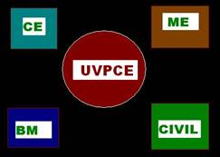

              Note :- Link the UVPCE,CE,ME,BM,CiVIL page for given image with

                         college Website.

**5.** Demonstrate the use of E-Mail Link using anchor tag.

**6.**Write HTML code to develop a webpage which covers all the above tags & tags of Practical-2 & 3 also.